3.1 System Architecture
Selected Architecture: Layered Architecture
The Moderated Learning Management System will use a four-layer architecture consisting of the Presentation Layer, Business Logic Layer, Data Access Layer, and Database Layer.
The Presentation Layer provides a simple console interface through which students, lecturers, Heads of Department (HoDs), and administrators interact with the system.
The Business Logic Layer implements the system's rules, including authentication, role-based access control, assignment submissions, deadline extensions, late penalties, marking, moderation, mark release, and audit logging.
The Data Access Layer manages communication with the database through repositories or Data Access Objects (DAOs). It performs database operations without requiring the presentation layer to understand SQL.
The Database Layer uses SQLite to store user accounts, departments, courses, enrolments, assignments, submissions, marks, feedback, and audit records.
Justification
Layered Architecture was selected because it provides a clear separation of responsibilities and is suitable for a small C++17 application using SQLite. It supports offline operation, makes the system easier to maintain and test, and helps ensure that business rules are enforced consistently regardless of which user interacts with the system.
The architecture also supports future database changes because database-specific operations are isolated in the Data Access Layer. The simple console interface supports the requirement that teachers should not need advanced IT skills.
Rejected Alternatives:
Model-View-Controller (MVC)
MVC separates an application into Model, View, and Controller components. Although it can be useful for applications with complex user interfaces, its additional separation is not necessary for the current console-based system. A four-layer design provides sufficient separation while remaining straightforward to implement and understand. MVC could be reconsidered if the system later develops a more complex graphical or web interface.
Client-Server / Microservices Architecture
The system is specified to run locally on a single school computer or local SQLite file without requiring an external database server. Introducing a client-server network architecture would add unnecessary network latency, deployment complexity, and configuration overhead, directly violating the Principal's simplicity constraint for non-IT expert teachers.
Component Diagram
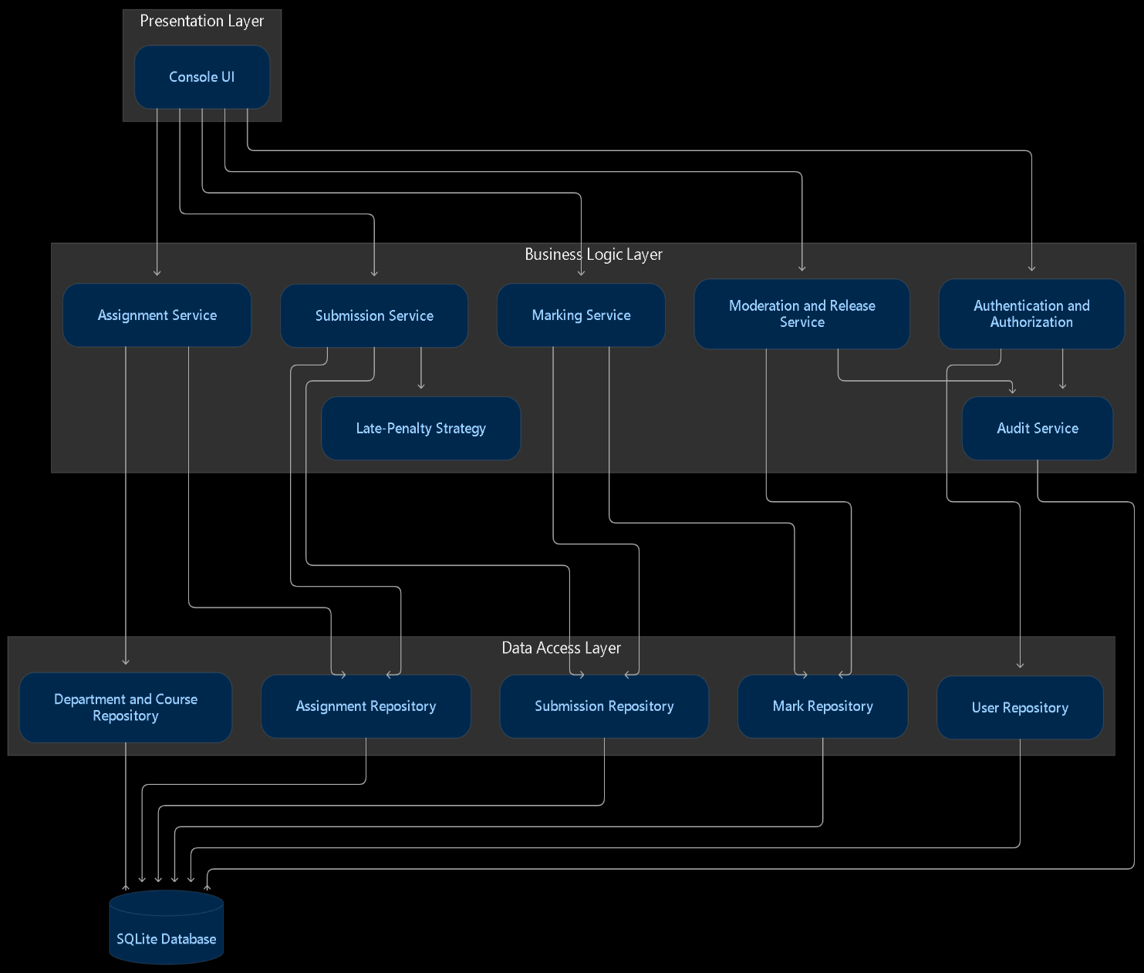

Console UI: accepts user input and displays results.
Business logic components: enforce system rules, including permissions, deadlines, penalties, marking, moderation, and release.
Repository components: retrieve and save information without exposing SQL details to the business logic.
SQLite Database: stores the persistent system data.
Late-Penalty Strategy: calculates the penalty according to the configured policy.

3.2 Class diagram and design patterns
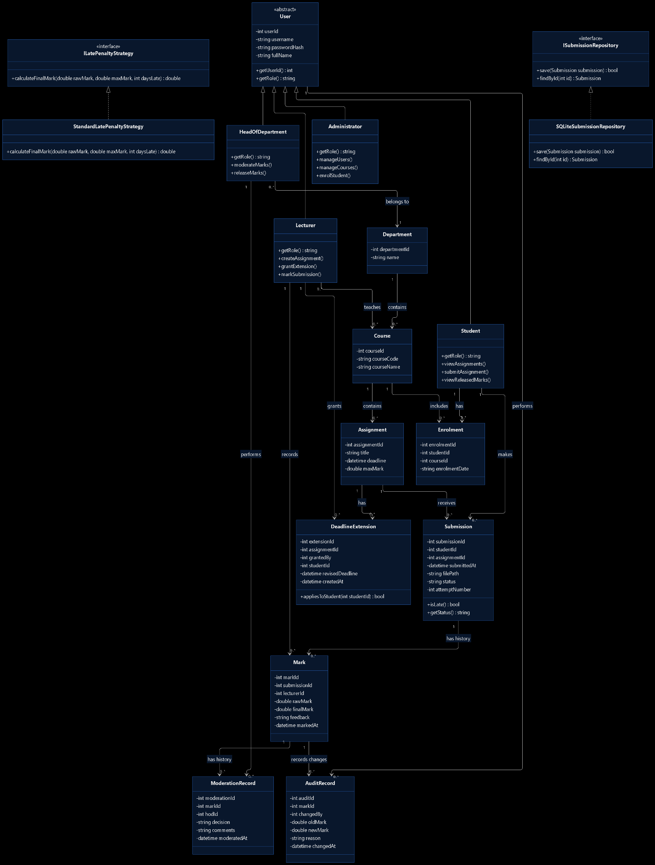

Design Patterns and SOLID Principles
Strategy Pattern: The system uses the ILatePenaltyStrategy interface and StandardLatePenaltyStrategy implementation to encapsulate the late-penalty calculation. This makes the policy independently testable and replaceable without coupling the submission workflow to one penalty algorithm.
Repository Pattern: The ISubmissionRepository interface separates submission persistence from business logic. SQLiteSubmissionRepository implements the interface and handles SQLite operations. This improves maintainability and supports testing without requiring the business logic to execute SQL directly.
The design applies SOLID principles through focused class responsibilities, replaceable penalty strategies, substitutable user subclasses, small interfaces, and dependencies on abstractions. These decisions support maintainability and testability while keeping the implementation appropriate for a C++17 application using SQLite.

3.3 Behavioural models: State Machine
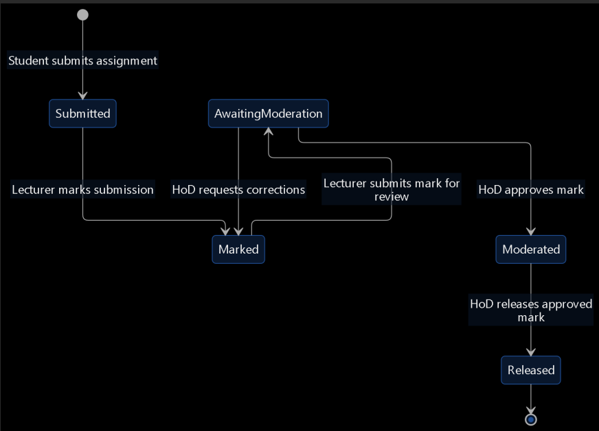

Activity Diagram with Swimlanes
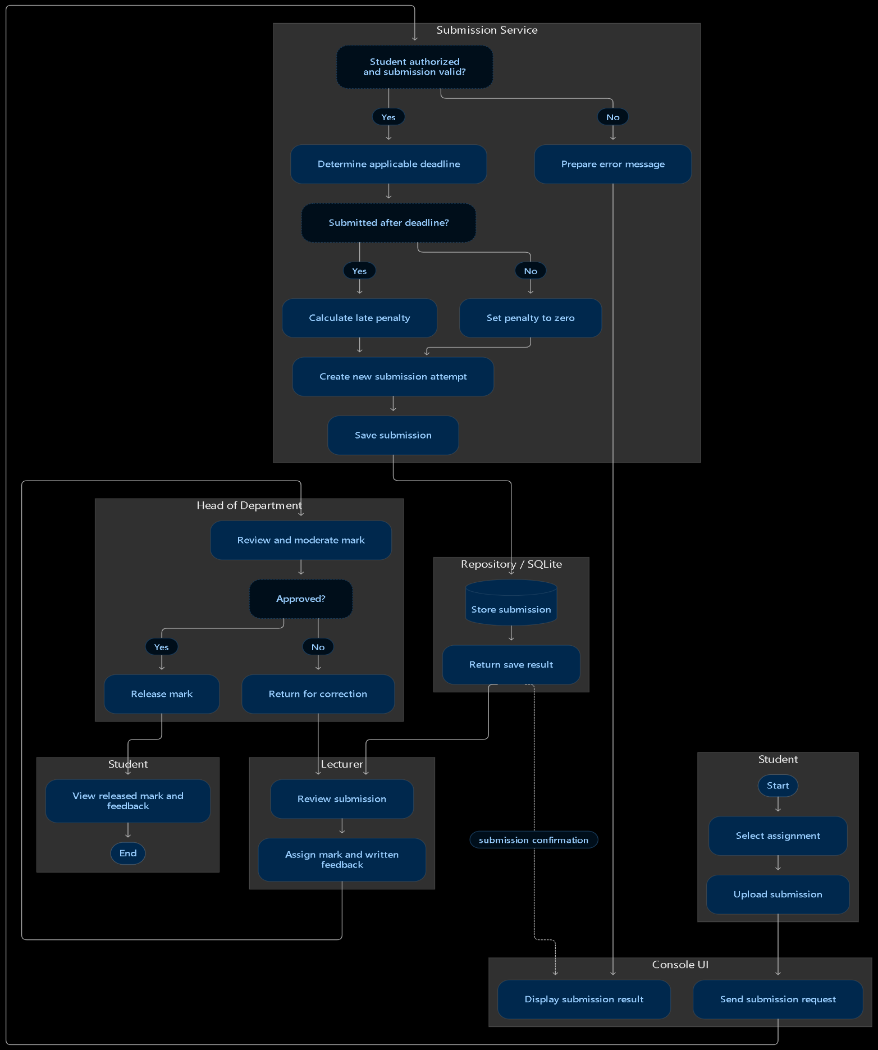
Sequence Diagrams
- Submit Assignment
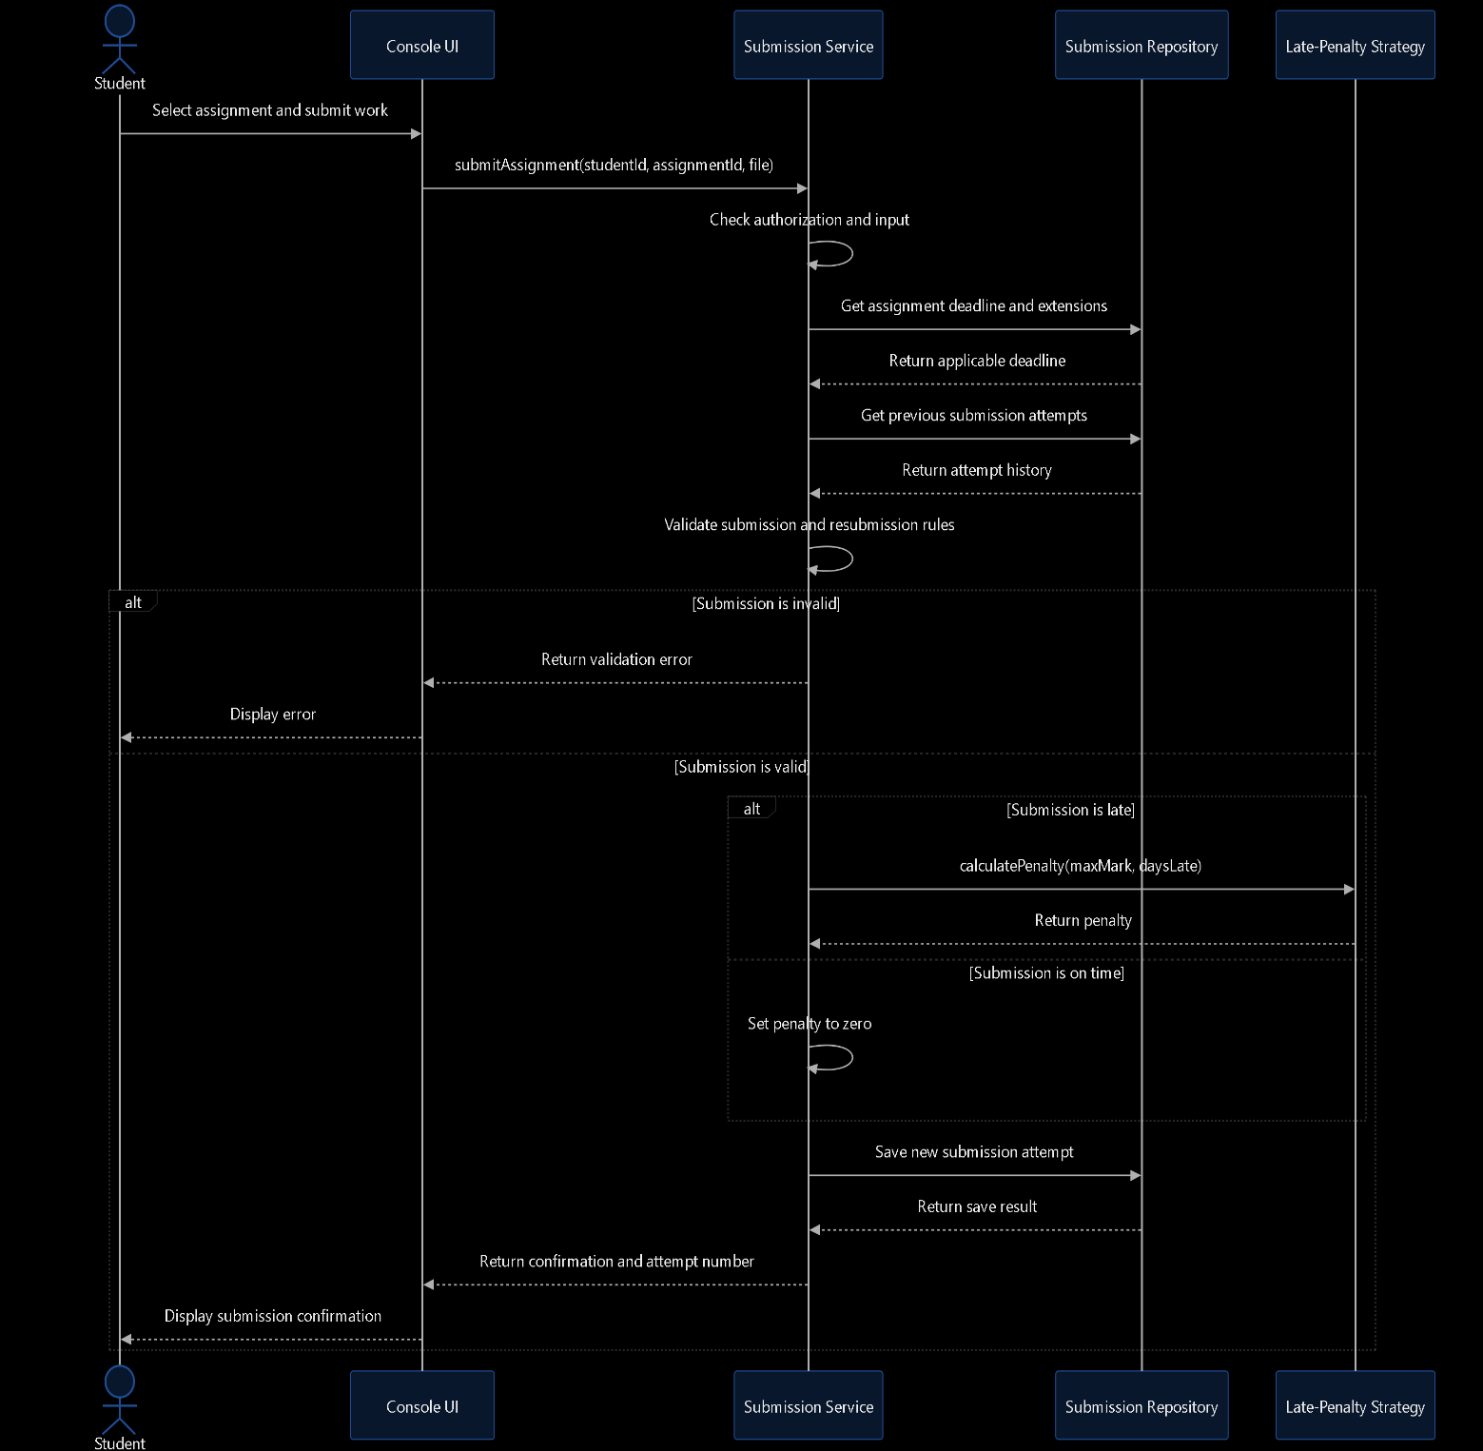
Late-penalty rule: 10% of the assignment's maximum mark per day late, for up to three days; work more than three days late receives zero under the stated policy. An approved extension must be applied before calculating lateness.
The strategy calculates the penalty; the submission service remains responsible for applying the rules and coordinating the process.
- Moderate and Release Marks

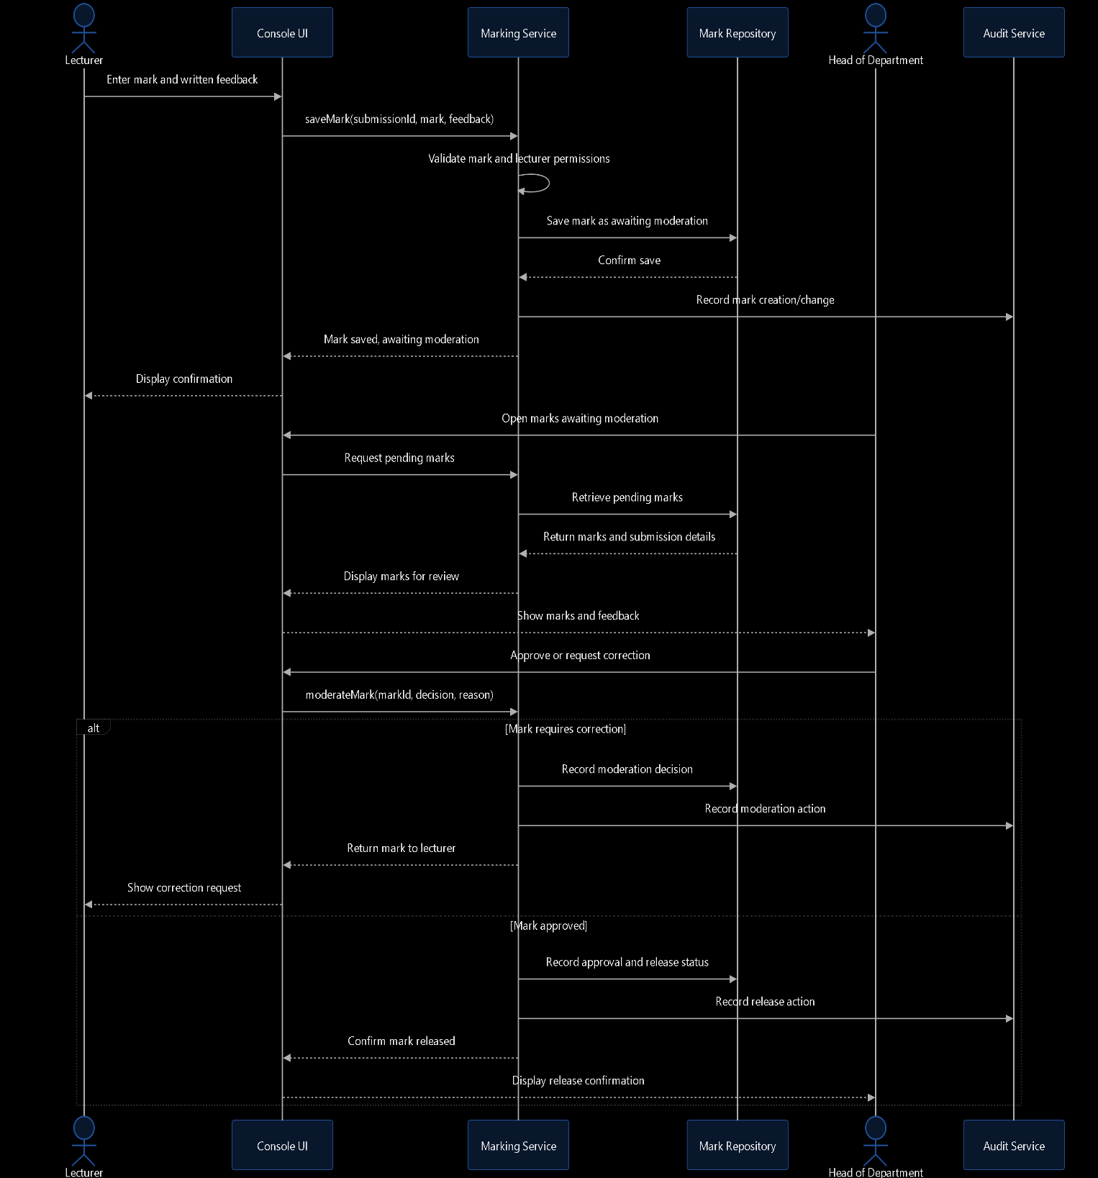

3.4 Database Design
ERD
ERD assumptions: USER stores common account information; role-specific tables store additional information. Each submission belongs to one student and one assignment. Each submission has at most one current mark, while moderation and audit records preserve the history of decisions and changes.
A whole-class extension has a NULL student_id; an individual extension has a specific student ID. The application must validate the extension's scope and use the correct deadline.

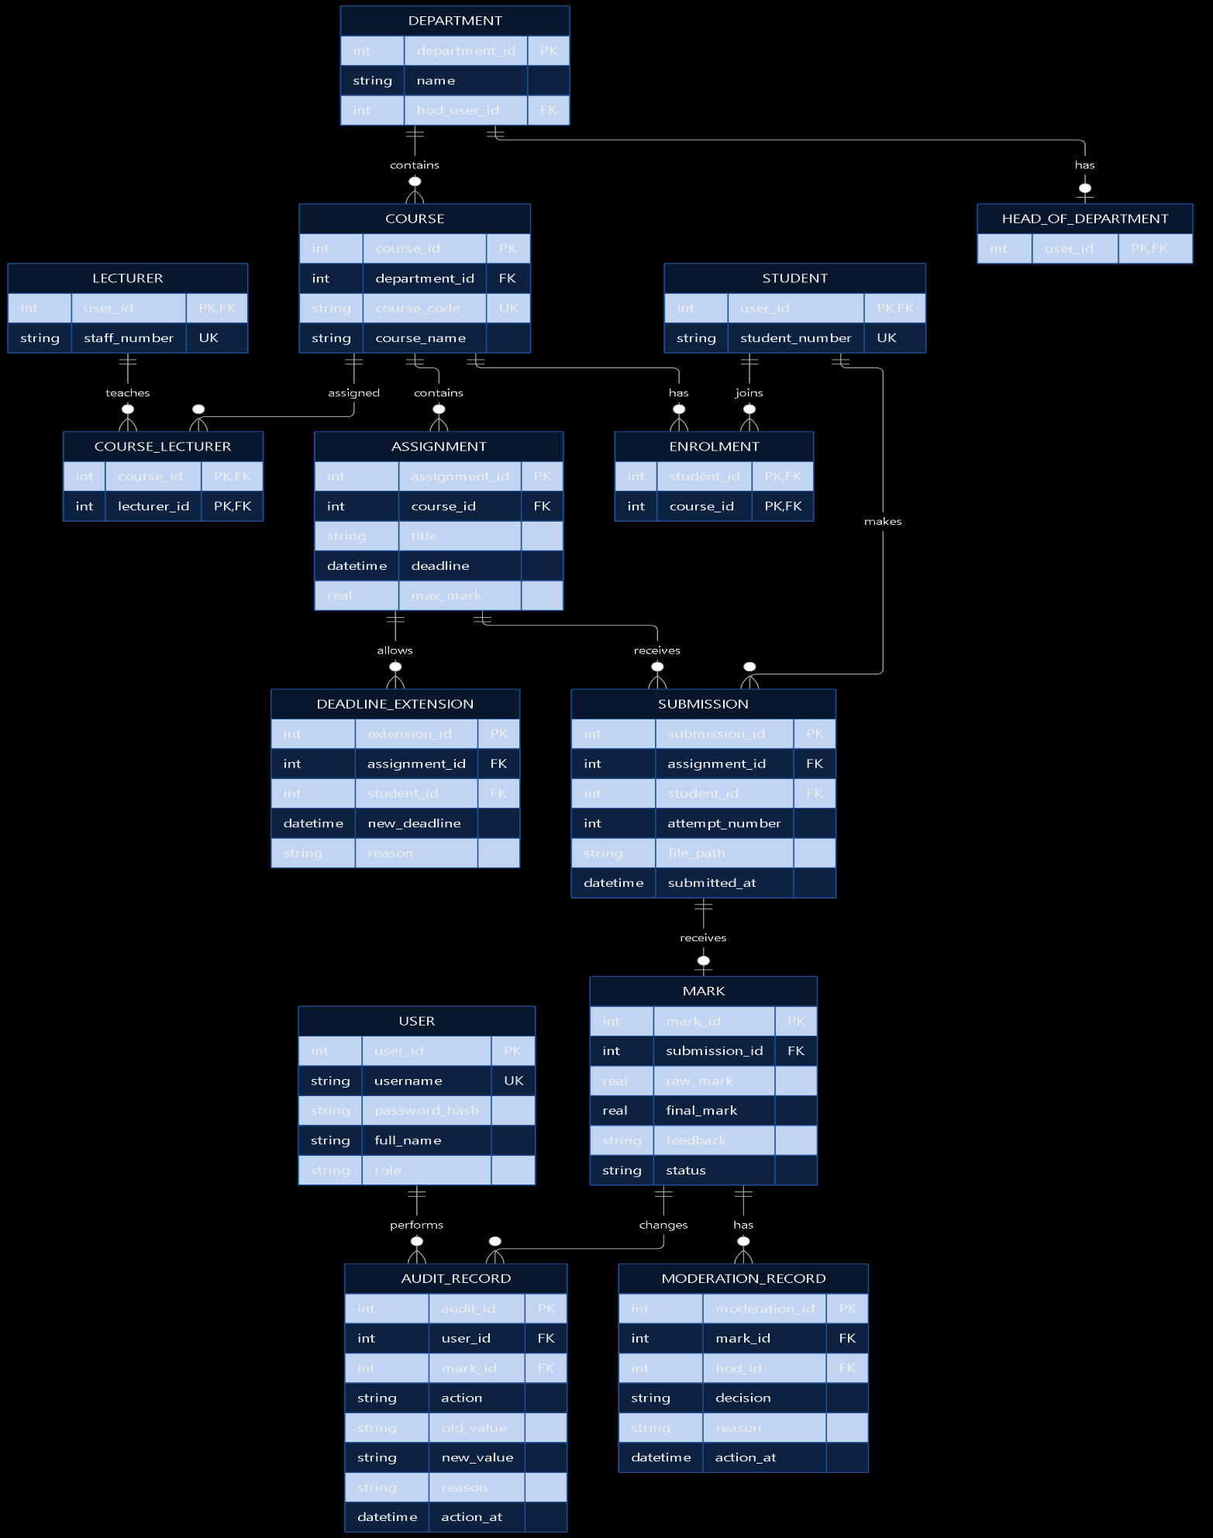
SQL Schema

PRAGMA foreign_keys = ON;

CREATE TABLE User (
user_id INTEGER PRIMARY KEY,
username TEXT NOT NULL UNIQUE,
password_hash TEXT NOT NULL,
full_name TEXT NOT NULL,
role TEXT NOT NULL CHECK (
role IN ('Student', 'Lecturer', 'HoD', 'Administrator')
)
);

CREATE TABLE Department (
department_id INTEGER PRIMARY KEY,
name TEXT NOT NULL UNIQUE,
hod_user_id INTEGER,
FOREIGN KEY (hod_user_id) REFERENCES User(user_id)
);

CREATE TABLE Student (
user_id INTEGER PRIMARY KEY,
student_number TEXT NOT NULL UNIQUE,
FOREIGN KEY (user_id) REFERENCES User(user_id)
);

CREATE TABLE Lecturer (
user_id INTEGER PRIMARY KEY,
staff_number TEXT NOT NULL UNIQUE,
FOREIGN KEY (user_id) REFERENCES User(user_id)
);

CREATE TABLE HeadOfDepartment (
user_id INTEGER PRIMARY KEY,
FOREIGN KEY (user_id) REFERENCES User(user_id)
);

CREATE TABLE Course (
course_id INTEGER PRIMARY KEY,
department_id INTEGER NOT NULL,
course_code TEXT NOT NULL UNIQUE,
course_name TEXT NOT NULL,
FOREIGN KEY (department_id) REFERENCES Department(department_id)
);

CREATE TABLE CourseLecturer (
course_id INTEGER NOT NULL,
lecturer_id INTEGER NOT NULL,
PRIMARY KEY (course_id, lecturer_id),
FOREIGN KEY (course_id) REFERENCES Course(course_id),
FOREIGN KEY (lecturer_id) REFERENCES Lecturer(user_id)
);

CREATE TABLE Enrolment (
student_id INTEGER NOT NULL,
course_id INTEGER NOT NULL,
PRIMARY KEY (student_id, course_id),
FOREIGN KEY (student_id) REFERENCES Student(user_id),
FOREIGN KEY (course_id) REFERENCES Course(course_id)
);

CREATE TABLE Assignment (
assignment_id INTEGER PRIMARY KEY,
course_id INTEGER NOT NULL,
title TEXT NOT NULL,
description TEXT,
deadline TEXT NOT NULL,
max_mark REAL NOT NULL CHECK (max_mark > 0),
FOREIGN KEY (course_id) REFERENCES Course(course_id)
);

CREATE TABLE DeadlineExtension (
extension_id INTEGER PRIMARY KEY,
assignment_id INTEGER NOT NULL,
student_id INTEGER,
new_deadline TEXT NOT NULL,
reason TEXT NOT NULL,
granted_by INTEGER NOT NULL,
FOREIGN KEY (assignment_id) REFERENCES Assignment(assignment_id),
FOREIGN KEY (student_id) REFERENCES Student(user_id),
FOREIGN KEY (granted_by) REFERENCES Lecturer(user_id)
);

CREATE TABLE Submission (
submission_id INTEGER PRIMARY KEY,
assignment_id INTEGER NOT NULL,
student_id INTEGER NOT NULL,
attempt_number INTEGER NOT NULL CHECK (attempt_number > 0),
file_path TEXT NOT NULL,
submitted_at TEXT NOT NULL,
UNIQUE (assignment_id, student_id, attempt_number),
FOREIGN KEY (assignment_id) REFERENCES Assignment(assignment_id),
FOREIGN KEY (student_id) REFERENCES Student(user_id)
);

CREATE TABLE Mark (
mark_id INTEGER PRIMARY KEY,
submission_id INTEGER NOT NULL UNIQUE,
raw_mark REAL NOT NULL CHECK (raw_mark >= 0),
final_mark REAL NOT NULL CHECK (final_mark >= 0),
feedback TEXT NOT NULL,
status TEXT NOT NULL CHECK (
status IN ('AwaitingModeration', 'CorrectionRequired',
'Approved', 'Released')
),
marked_by INTEGER NOT NULL,
marked_at TEXT NOT NULL,
FOREIGN KEY (submission_id) REFERENCES Submission(submission_id),
FOREIGN KEY (marked_by) REFERENCES Lecturer(user_id)
);

CREATE TABLE ModerationRecord (
moderation_id INTEGER PRIMARY KEY,
mark_id INTEGER NOT NULL,
hod_id INTEGER NOT NULL,
decision TEXT NOT NULL CHECK (
decision IN ('Approved', 'CorrectionRequired')
),
reason TEXT,
action_at TEXT NOT NULL,
FOREIGN KEY (mark_id) REFERENCES Mark(mark_id),
FOREIGN KEY (hod_id) REFERENCES HeadOfDepartment(user_id)
);

CREATE TABLE AuditRecord (
audit_id INTEGER PRIMARY KEY,
user_id INTEGER NOT NULL,
mark_id INTEGER,
action TEXT NOT NULL,
old_value TEXT,
new_value TEXT,
reason TEXT,
action_at TEXT NOT NULL,
FOREIGN KEY (user_id) REFERENCES User(user_id),
FOREIGN KEY (mark_id) REFERENCES Mark(mark_id)
);

Table Dictionary
Table | Purpose | Important fields
User | Common account and login details | user_id, username, password_hash, role
Department | Academic departments | department_id, hod_user_id
Student | Student-specific details | user_id, student_number
Lecturer | Lecturer-specific details | user_id, staff_number
HeadOfDepartment | HoD role identity | user_id
Course | Courses offered by departments | course_id, course_code
CourseLecturer | Lecturer-course assignments | course_id, lecturer_id
Enrolment | Student-course relationships | student_id, course_id
Assignment | Assignment details and deadlines | assignment_id, deadline, max_mark
DeadlineExtension | Individual and whole-class extensions | assignment_id, nullable student_id, new_deadline
Submission | Each submitted attempt | attempt_number, submitted_at, file_path
Mark | Current mark and feedback for a submission | raw_mark, final_mark, status
ModerationRecord | HoD moderation decisions | decision, reason, action_at
AuditRecord | Record of mark-related actions | old_value, new_value, user_id, action_at

Normalization to Third Normal Form (3NF)
The proposed database is designed around these principles:
- First Normal Form (1NF): Each field stores a single value. Multiple submissions are stored as separate rows, not as lists in one field.
- Second Normal Form (2NF): In tables with composite keys, such as Enrolment and CourseLecturer, non-key attributes depend on the entire key.
- Third Normal Form (3NF): Student, lecturer, course, and department details are stored in their own tables rather than repeatedly copied into assignments or submissions. Role-specific details are separated from common user details.
This reduces duplication and helps maintain consistency when details change.

Class-to-table mapping
Design class | Database table(s) | Reason
User | User | Common account details
Student | Student | Student-specific details
Lecturer | Lecturer | Lecturer-specific details
HeadOfDepartment | HeadOfDepartment | HoD identity and role
Department | Department | Department details
Course | Course, CourseLecturer | Course data and lecturer assignments
Enrolment | Enrolment | Many-to-many student-course relationship
Assignment | Assignment | Assignment information
DeadlineExtension | DeadlineExtension | Extension scope and new deadline
Submission | Submission | One row per attempt
Mark | Mark | Current mark, feedback, and status
ModerationRecord | ModerationRecord | Moderation history
AuditRecord | AuditRecord | Audit trail
ILatePenaltyStrategy and StandardLatePenaltyStrategy | No direct table | Business logic; calculate penalties
ISubmissionRepository and SQLiteSubmissionRepository | No direct table | Interfaces and data-access implementation

